**Vectors in Component Form:**

We can use these methods where there are more than 2 vectors being applied to an object

Unit vectors

We use I and j to help with illustrating vectors.

**Don’t forget the curly line underneath I and j

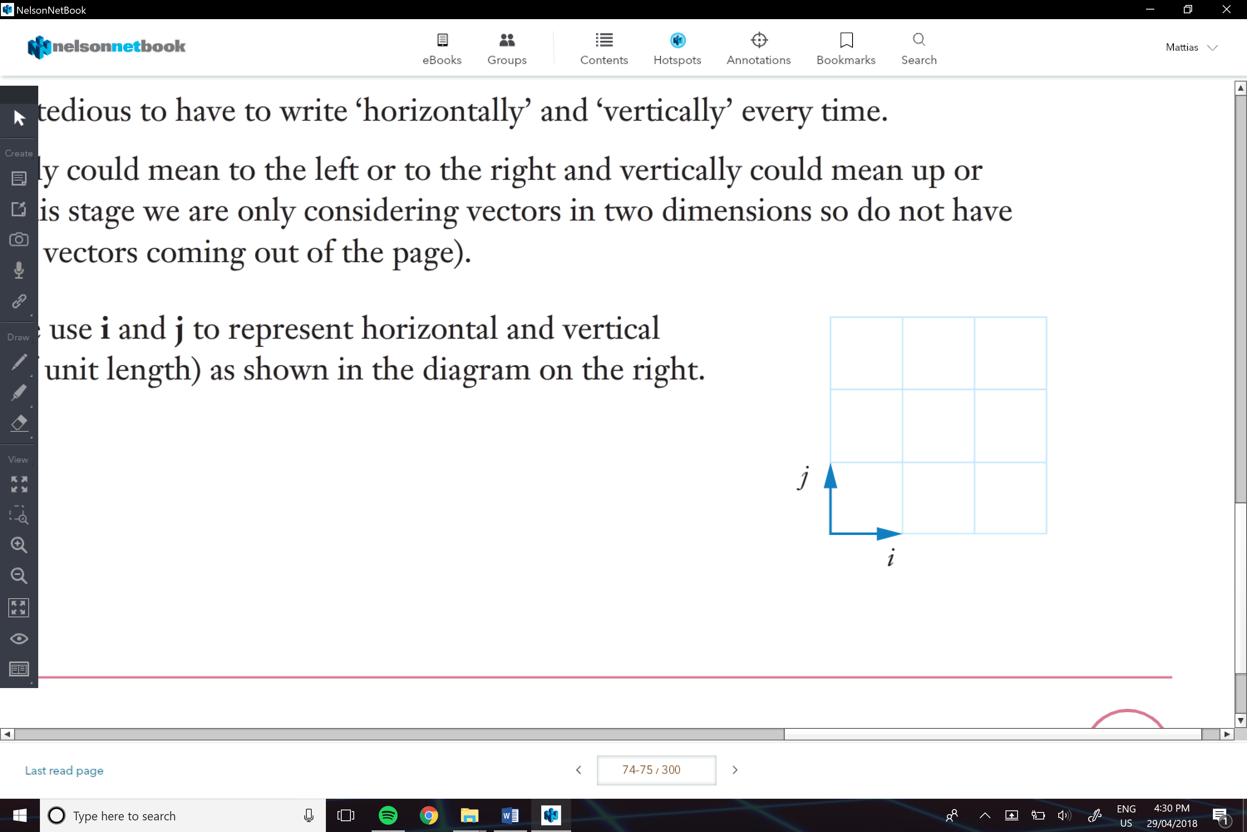

We can also use, sin and cos to help us to figure out the resultant for multiple vectors

e.g.

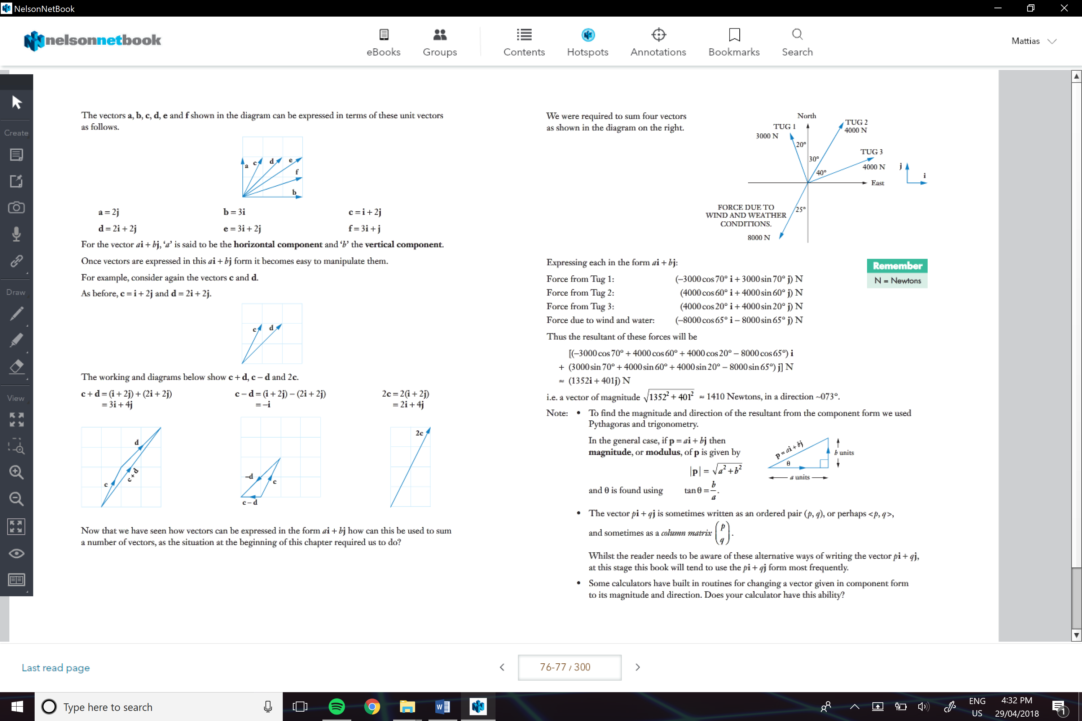

Unit Vector:

Would be a vector in the same direction but only of one unit

* To figure it out we find out the magnitude and divide the I and k units by the

We can use this to help us do more calculations:

e.g.

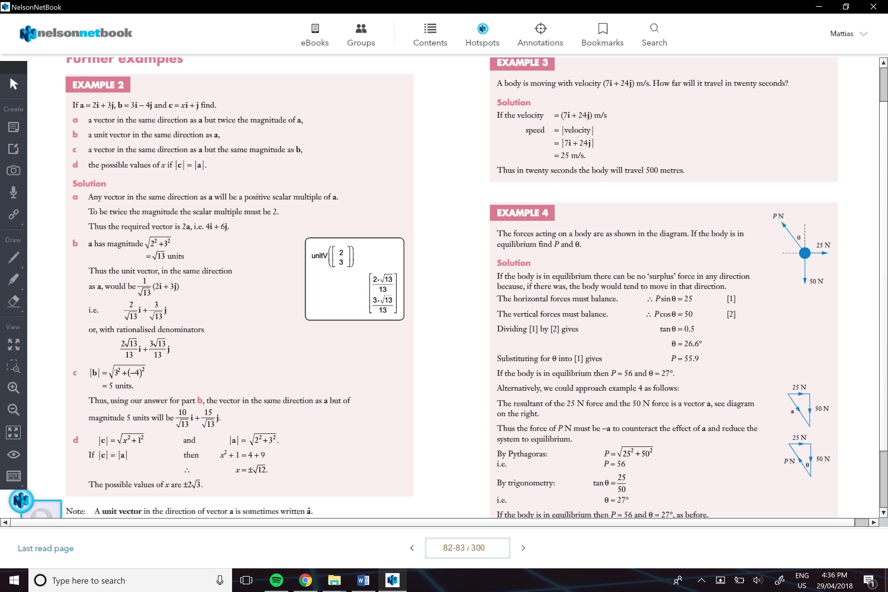

e.g.

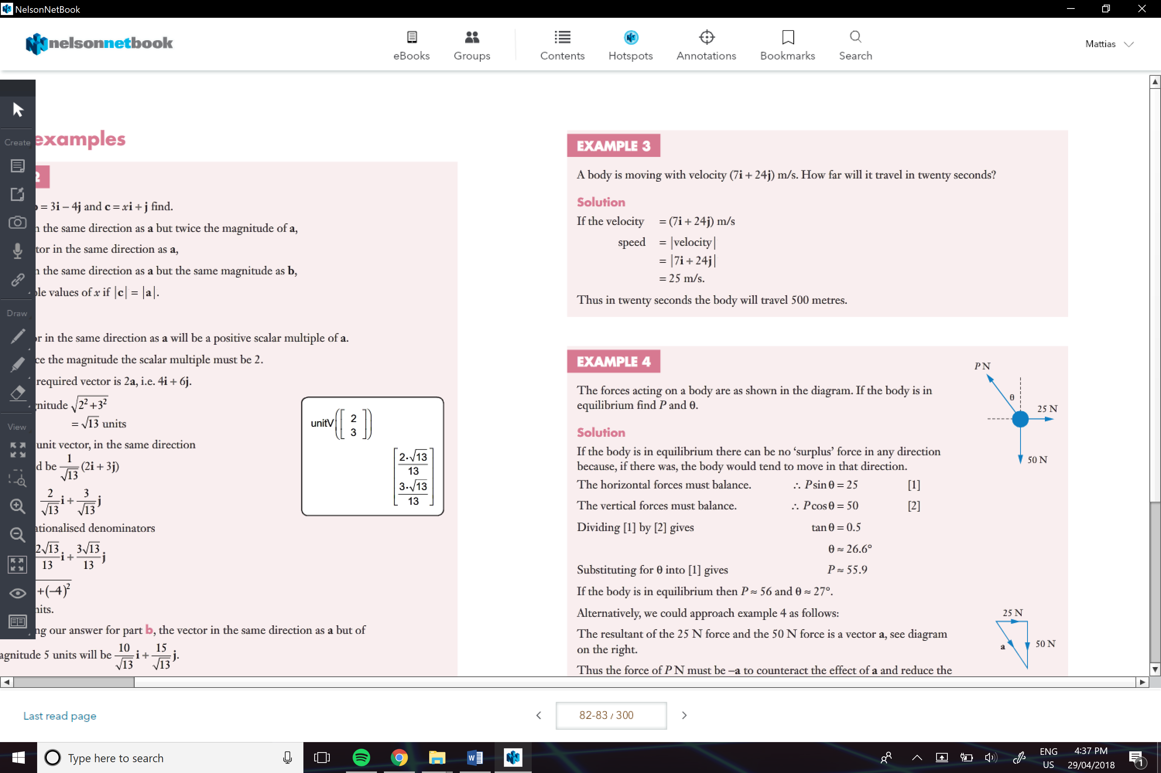

Equilibrium forces:

There are two approaches we could use, but the better one is

* Find the resultant of the forces
* The equal force will be the negative vector, so it will have the same magnitude
* Then by using trig we can find the direction

e.g.

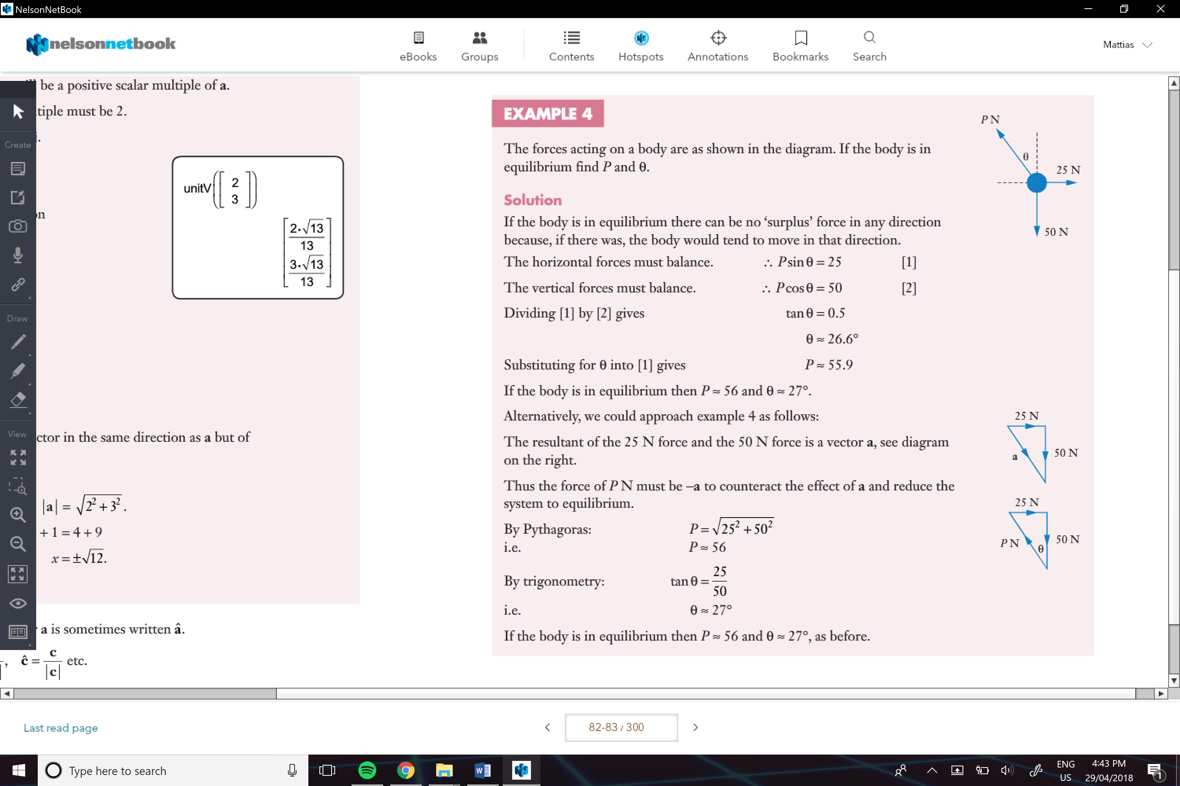

Base Vectors:

Can be used when horizontal and vertical vectors are not useful

* We will normally get given a form and then we can equate the I and j components and then solve

e.g.

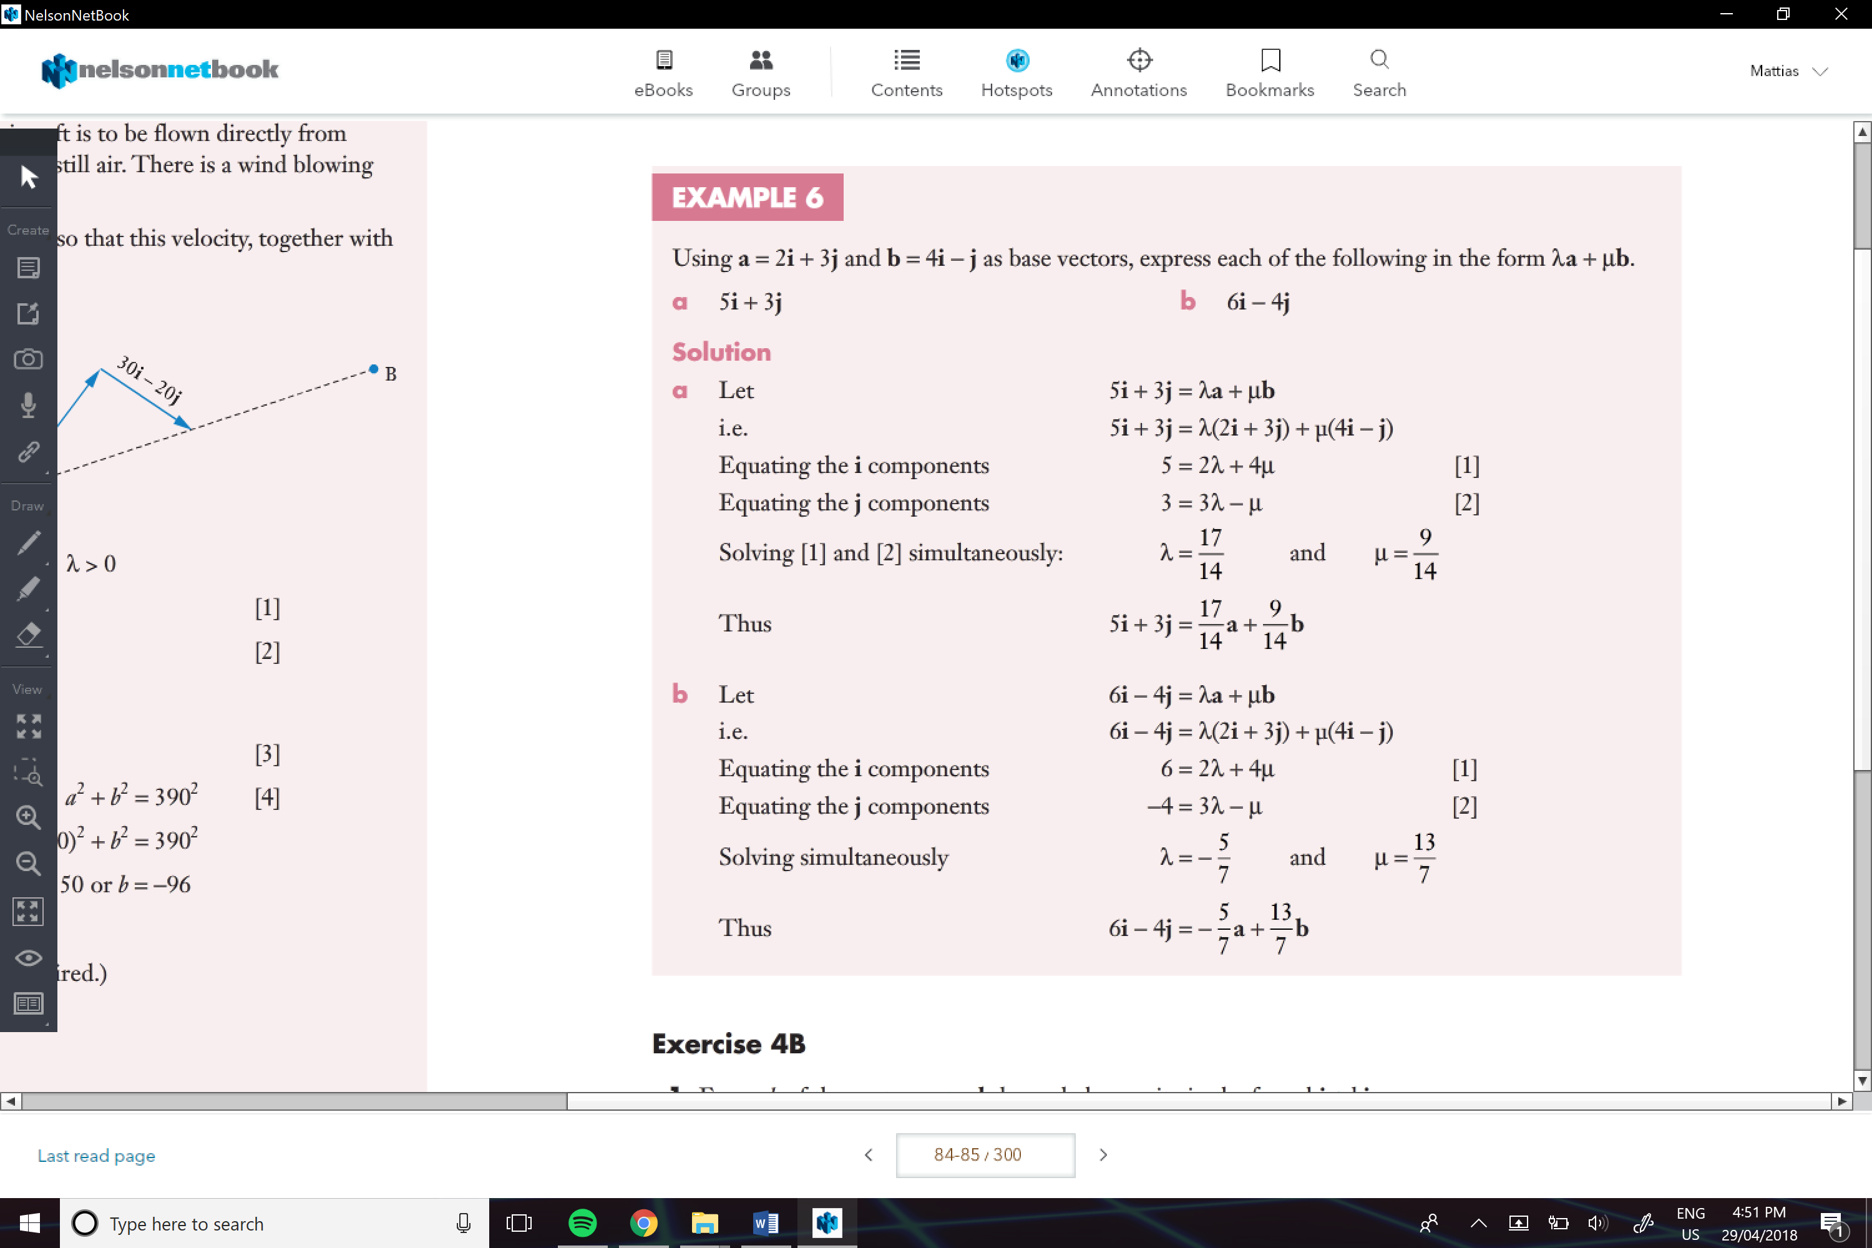

**COME BACK TO THIS**

e.g.

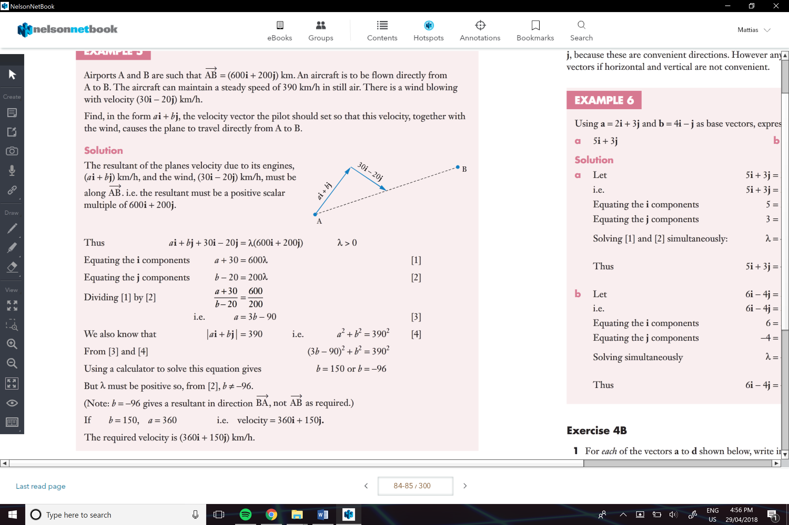

DON’T FORGET THE DIAGRAM

Position Vectors:

Are vectors from the origin to that point in the I and j form

* We can use positional vectors to help us find certain vectors

e.g.

